LAB 3

2. CITIES AND TEMPERATURES

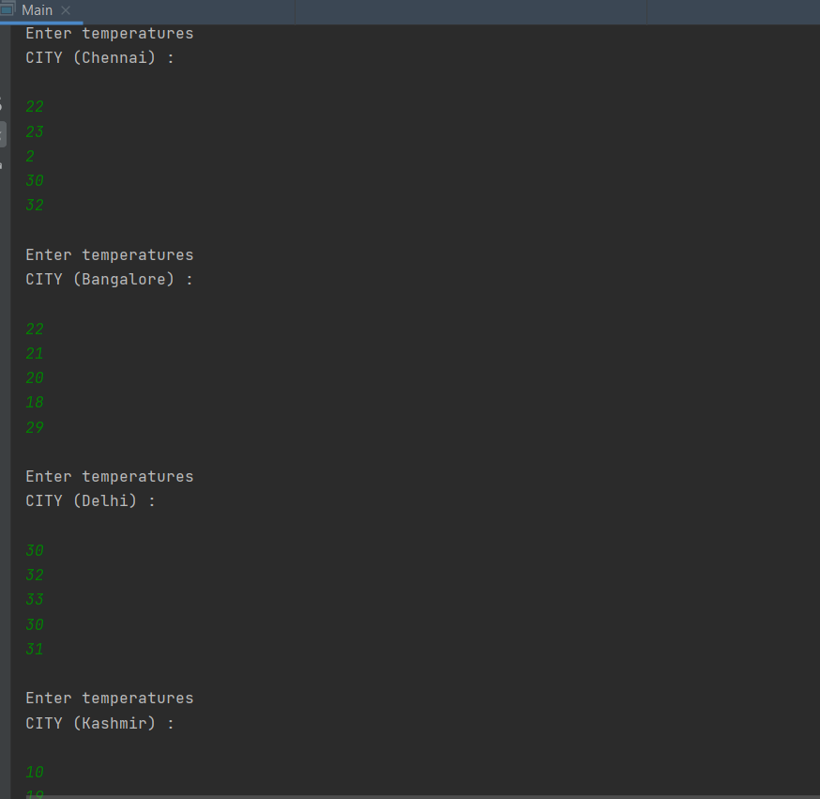

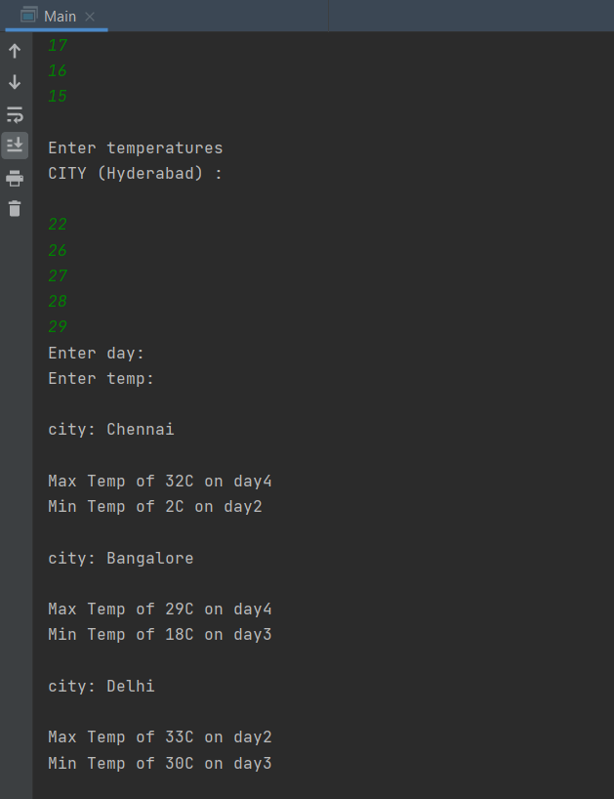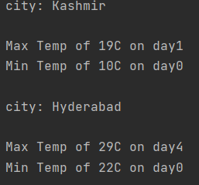

CODE:

package com.company;  
import java.util.Scanner;  
public class Main {  
 public static void main(String[] arg){  
 Scanner n= new Scanner(System.*in*);  
 int i,j,ele;  
 int arr[][]= new int[5][5];  
 //{{19,21,23,22,20},{10,9,8,7,6},{27,28,29,30,31},{32,33,32,34,35},{27,26,25,24,23}};  
 String city[]={"Chennai", "Bangalore", "Delhi", "Kashmir", "Hyderabad"};  
 for(i=0; i<=4; i++) {  
  
 System.*out*.println("\nEnter temperatures\nCITY (" + city[i] + ") :\n");  
 for(j=0; j<=4; j++){  
 ele=n.nextInt();  
 arr[i][j]=ele;  
 }  
 }  
 System.*out*.println("Enter day: ");  
 //int day=n.nextInt();  
 //int dayc=day-1;  
 int maxtemp=0;  
 int mintemp=0;  
 int minday=1;  
 int maxday=1;  
 System.*out*.println("Enter temp: ");  
 //int temp=n.nextInt();  
 for(i=0; i<=4; i++)  
 { maxtemp=arr[i][0];  
 mintemp=arr[i][0];  
 for(j=0; j<=4; j++)  
 {  
 if(maxtemp<=arr[i][j])  
 { maxtemp=arr[i][j];  
 maxday=j;  
 }  
  
 if(mintemp>=arr[i][j])  
 { mintemp=arr[i][j];  
 minday=j;  
 }  
  
 }  
 System.*out*.println("\ncity: "+city[i]+"\n");  
 System.*out*.println("Max Temp of "+maxtemp+"C on day"+maxday);  
 System.*out*.println("Min Temp of "+mintemp+"C on day"+minday);  
 }  
 }  
  
  
  
 }

3. BALLOTS

CODE:

package com.company;  
import java.util.Scanner;  
public class Main  
{  
 public static void main(String args[]){  
 Scanner in=new Scanner(System.*in*);  
  
 int i,n,j,spoilt=0;  
 System.*out*.println("Enter number of ballots: ");  
 n = in.nextInt();  
 //int count[] = new int[n]; start here  
 int count[]={0,0,0,0,0};  
 int vote[]= new int[10];  
 System.*out*.println("Enter choice for");  
 for(i=0; i<n; i++){  
 System.*out*.println("ballot "+i+" :");  
 vote[i]=in.nextInt();  
 }  
  
 for(i=0;i<n-1;i++)  
  
 {  
  
 if( vote[i] == 1)  
 {  
 count[0]++;  
 }  
 else if(vote[i]== 2)  
 {  
 count[1]++;  
 }  
 else if(vote[i]== 3)  
 {  
 count[2]++;  
 }  
 else if(vote[i]== 4)  
 {  
 count[3]++;  
 }  
 else if(vote[i]== 5)  
 {  
 count[4]++;  
 }  
 else  
 {  
  
 spoilt++;  
 }  
 }  
 System.*out*.println("ballot paper: " );  
 System.*out*.println("1: "+count[0]);  
 System.*out*.println("2: "+count[1]);  
 System.*out*.println("3: "+count[2]);  
 System.*out*.println("4: "+count[3]);  
 System.*out*.println("5: "+count[4]);  
 System.*out*.println("spoilt ballots are : " + spoilt);  
 }  
}

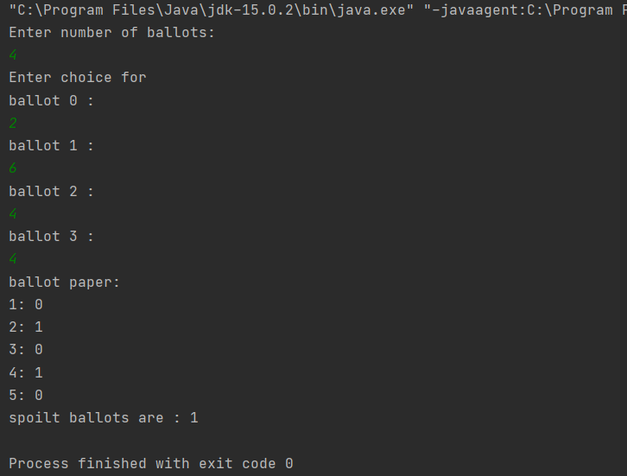

1. MEDALS

CODE:

package com.company;  
import java.util.Scanner;  
import java.util.Arrays;  
class medal{  
 public static int countryTotal(String countryname, int [][] medalTally){  
 int sum=0;  
 if(countryname.equalsIgnoreCase("india")){  
 for(int i=0;i<3;i++) {  
 sum += medalTally[0][i];  
 }  
 }  
 else if(countryname.equalsIgnoreCase("america"))  
 {  
 for(int i=0;i<3;i++){  
 sum += medalTally[1][i];  
 }  
 }  
 else{  
 for(int i=0;i<3;i++) {  
 sum += medalTally[2][i];  
 }  
 }  
 return sum;  
 }  
 public static int medalwise(String medaltype, int [][] medalTally)  
 {  
 int sum=0;  
 if(medaltype.equalsIgnoreCase("gold")){  
 for(int i=0;i<3;i++) {  
 sum += medalTally[i][0];  
 }  
 }  
 else if(medaltype.equalsIgnoreCase("silver"))  
 {  
 for(int i=0;i<3;i++){  
 sum += medalTally[i][1];  
 }  
 }  
 else{  
 for(int i=0;i<3;i++) {  
 sum += medalTally[i][2];  
 }  
 }  
 return sum;  
 }  
 public static int position(int [][] medalTally)  
 {  
 int india = *countryTotal*("india", medalTally);  
 int america = *countryTotal*("america",medalTally);  
 int japan = *countryTotal*("japan",medalTally);  
 int a[] = {india,america,japan};  
 System.*out*.println("India "+india+" America "+america+" japan "+japan);  
 Arrays.*sort*(a);  
 return 3-Arrays.*binarySearch*(a,india);  
 }  
}  
public class Main{  
 public static void main(String[] args){  
 medal M = new medal();  
 Scanner in = new Scanner(System.*in*);  
 int [][] input = new int [3][3];  
 System.*out*.println("Enter Inputs:");  
 for(int i=0;i<3;i++) {  
  
 for (int j = 0; j < 3; j++) {  
  
 input[i][j] = in.nextInt();  
 }  
 }  
 int gold = M.*medalwise*("gold",input);  
 int silver = M.*medalwise*("silver",input);  
 int bronze = M.*medalwise*("bronze",input);  
 System.*out*.println("Gold "+gold+"\n Silver "+silver+"\n bronze"+bronze);  
 int pos = M.*position*(input);  
 System.*out*.println("Position:"+pos);  
 }  
}

